Project Design Phase-II
Data Flow Diagram & User Stories

Date | 31 January 2025
Team ID | SWTID-2026-6064
Project Name | Streamlining IT Procurement: Automating Standard Laptop Orders with Flow Designer
Maximum Marks | 4 Marks

Data Flow Diagrams:
A Data Flow Diagram (DFD) is a traditional visual representation of the information flows within a system. A neat and clear DFD can depict the right amount of the system requirement graphically. It shows how data enters and leaves the system, what changes the information, and where data is stored.
DFD Level 0 – Automated Standard Laptop Procurement
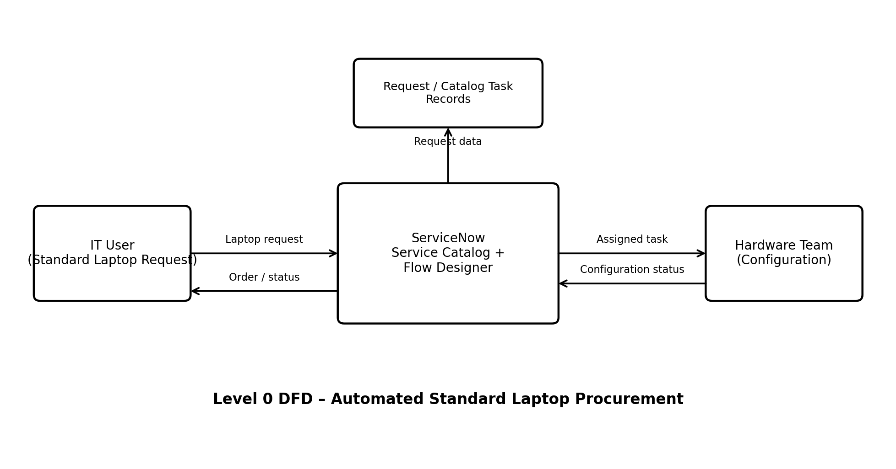


DFD entities and flows: IT User → ServiceNow Service Catalog → Approval → Flow Designer → Catalog Task → Hardware Team. Request and task information is maintained in the ServiceNow request/task records.
User Stories
Use the below template to list all the user stories for the product.
User Type | Functional Requirement (Epic) | User Story Number | User Story / Task | Acceptance criteria | Priority | Release
IT User | Standard Laptop Request | USN-1 | As an IT user, I can place a standard laptop request through the Service Catalog. | A standard laptop request can be submitted and a request record is created. | High | Sprint-1
IT User | Standard Laptop Request | USN-2 | As an IT user, I can view the status of my standard laptop request. | The request/order status can be viewed in the ServiceNow request record. | High | Sprint-1
IT Procurement Team | Approval | USN-3 | As a member of the IT procurement team, I can process the approval for a standard laptop request. | The requested item shows the approval status and can be approved before task creation. | High | Sprint-1
IT Procurement Team | Automated Task Creation | USN-4 | As a member of the IT procurement team, I want Flow Designer to automatically create a Catalog Task after approval. | After approval, a Catalog Task is created automatically for the requested item. | High | Sprint-1
IT Procurement Team | Task Assignment | USN-5 | As a member of the IT procurement team, I want the configuration task to be assigned automatically to the Hardware group. | The Catalog Task has Assignment group set to Hardware. | High | Sprint-1
Hardware Team | Laptop Configuration | USN-6 | As a hardware team member, I can receive the standard laptop configuration task. | The Hardware team can see the assigned Catalog Task with the required laptop configuration description. | High | Sprint-1
Hardware Team | Task Tracking | USN-7 | As a hardware team member, I can update the status of the laptop configuration task. | The Catalog Task record reflects the current task status. | Medium | Sprint-2
IT Procurement Team | Workflow Automation | USN-8 | As an IT procurement team member, I can use the Standard Laptop Task Flow instead of manual task creation. | The Standard Laptop Task Flow is activated and linked to the Standard Laptop service catalog item. | High | Sprint-2

